EVACUATION ANNEX

I. Purpose

The purpose of this annex is to provide procedures for the orderly and coordinated evacuation of residents of Lawrence County due to any emergency situation.

II. Situation and Assumptions

A. Situation

1. Residents of Lawrence County may be advised to evacuate due to various emergency operations, including, but not limited to, fire, flooding, hazardous materials release, etc.

2. There are two types of evacuations that may be utilized: general and limited.

a) A general evacuation would involve the relocation of a large portion of the public from a risk area. (NOTE: Lawrence County has been designated a host area in respect to nuclear attack, meaning we are not a target area and persons living in a target area would relocate to Lawrence County.

b ) A limited evacuation would involve the relocation of a smaller portion of the public from a risk area.

3. General evacuation routes have been designated for use when evacuating from the risk area.

B. Assumptions

1. First responders (fire, police, EMS, rescue) will usually be able to recognize a situation requiring an evacuation, and would initiate initial evacuation recommendations and procedures.

2. The annex focuses on hazards that provide sufficient warning time to implement a planned evacuation for people identified as being at risk in the jurisdiction.

3. Some residents may refuse to evacuate after being advised to do so, as is their right in Illinois.

4. Most evacuees would try to relocate with friends or relatives,
or go to a hotel/motel, rather than go to a public shelter.

5. Since Lawrence County has been designated a host area,
there would be an increase in population during a period
of international crisis.

6. Residents may try to re-enter a risk area before safe to do so.

7. Spontaneous evacuation will occur when there is sufficient warning of the threat. Between 5 and 20 percent of the people at risk will evacuate before being directed to do so.

8. Some owners of companion animals will refuse to evacuate unless arrangements have been made to care for their animals.

9. Roughly 20 percent of the population at risk will require shelter in a mass care facility. Many evacuees will seek shelter with relatives, friends, or motels rather than use government-provided mass care facilities.

10. Where available, Illinois National Guard ( as approved by the Governor) will be available to support evacuation efforts.

11. Evacuation of people at risk for emergency situations that occur with little or no warning will be implemented on an ad hoc basis. The individual responsible for implementing it should be the IC at the scene of the emergency, with support arranged through the EOC as necessary. Evacuation instructions should be based on known or assumed health risks associated with the hazard.

III. Concept of Operations

A. The Lawrence County ESDA Coordinator will designate general evacuation routes for residents to use. At the time of general evacuation, the ESDA Coordinator will designate areas along the route where evacuees can obtain fuel, water, medical aid, vehicle repair/maintenance, information, and comfort facilities, as well as recommended destinations.

B. Emergency responders (fire, police, EMS, rescue) would be the first on scene to an emergency, or potential emergency, requiring an evacuation. They may recommend evacuation to residents, taking into consideration the following characteristics of the emergency:

1. Magnitude of the emergency.

2. Intensity of the emergency.

3. Time until onset.

4. Expected duration of the emergency.

C. Following the evacuation recommendation by an emergency response organization, the Lawrence County Sheriff shall be notified and will coordinate the evacuation effort, including:

1. Identifying the number of people requiring transportation to evacuate.

2. Designating an assembly point for evacuees without their own transportation for assembly.

3. Arranging transportation for evacuees without their own vehicles.

4. Arranging shelters to house evacuees.

5. Providing evacuation information to the local media to be disseminated.

D. Provisions, to the extent possible, will be made for providing the elderly, persons with mobility impairments, the handicapped, and hospital/nursing home patients proper transportation methods, medical assistance, and other related support during emergency situations.

E. The Lawrence County Sheriff will be responsible for evacuating Lawrence County jail inmates.

F. The Lawrence County Sheriff with the local municipal police agency is responsible for overseeing and controlling of evacuation routes.

G. School personnel will be responsible for evacuating students.

H. For major evacuations the Emergency Operations Center (EOC) will be activated. Decisions will be made at the EOC and transmitted to the Incident Command Post.

I. Evacuees should use the designated evacuation routes. This will allow emergency personnel to monitor and evaluate evacuation operations.

J. Impediments to evacuation must be countered to ensure effective evacuation operations. If an evacuation becomes blocked due to a physical barrier, traffic congestion, etc., action must be taken to either remove the barrier or to establish another evacuation route and reroute the traffic. Inoperable vehicles must be moved to the side of the road or towed away to keep traffic moving.

K. If there is not enough time to acquire transportation for persons without their own mode of transportation, or if there is a shortfall of vehicles for transportation, officials should request persons with vehicles who are evacuating to give the persons without a vehicle a ride to the shelter. Able-bodied evacuees may be asked to walk to the nearest assembly point to wait for transportation. As a last resort, officials may recommend in-place sheltering.

L. Should efforts of public response agencies be inadequate, assistance from the private sector and local voluntary organizations will be requested. The ESDA Coordinator will maintain a list of local organizations who could assist in evacuation operations.

M. Each agency/organization providing evacuation assistance shall arrange for the activation and release of their personnel to provide for a continuous 24-hour manning of jobs during emergency operations. In addition, each organization will be responsible for providing necessary logistical support for their personnel.

N. If all local efforts have been exhausted, assistance in evacuation operations will be requested from nearby jurisdictions, or the state, or federal government. Assistance requests to nearby jurisdictions should be done directly to the jurisdiction. Requests to the state or federal government should be directed to the IEMA.

O. See also Mass Care Annex, and Public Works Annex for more assignment of responsibilities and procedures to be used.

P. If necessary, coordination with a host jurisdiction will be conducted
to ensure adequate sheltering for evacuees.

Q. Any radiological response personnel from the state or federal government teams will be notified, if appropriate, to provide radiological decontamination of response personnel, equipment, supplies, instruments, facilities, and civilians.
R. Each emergency response organization is responsible for identifying any specific emergency authorities that can be assumed by the designated successors. These authorities should be outlined in an SOP.

1. The successors emergency authority will become effective upon the unavailability of the authority. The authority may, upon necessity, appoint the successor to fulfill his duties upon his inability to serve, such as sickness, injury, or commitment elsewhere.

2. When a succession has been made and someone assumes responsibility for a particular function, all agencies will be notified. This will be done by making the announcement in the EOC and having each EOC member relay the information to their agencies. The alternate method will be to have the ESDA communications center make the announcement.

S. Re-entry into the evacuation area will only be allowed after it is determined by the appropriate officials that it is safe to do so. Technical advice from the state or federal officials may be necessary in some instances (radiological, hazardous materials type incidents, etc.)

T. The Lawrence County Highway Department in conjunction with the Sheriff and ESDA Coordinator should review all identified evacuation routes to assess potential problem areas.

U. There are no mutual aid agreements negotiated, coordinated, or prepared at this time.

V. Transients

1. Hotel and motel guests will be expected to use their own modes of transportation for evacuation.

2. Street people and those lacking transportation will be transported via public vehicles.

W. Commercial radio stations will be the primary means of keeping the evacuees and general public informed.

X. Assembly areas for picking up people will be selected by the Evacuation Coordinator.

Y. Access to controlled areas will be controlled by law enforcement. Persons wishing access must show proper identification. Law enforcement will patrol all evacuated areas unless officers are at risk.

Z. There are no mutual aid agreements for moving or sheltering evacuees.

AA. The hospital is responsible for arranging the evacuation of patients.

IV. Organization and Assignment of Responsibilities

A. Chief Executive Official (CEO)

1. Requires the evacuation coordinator to report to the EOC when notified of an emergency situation.

2. Issues a statement on the jurisdiction’s policy on people that do not comply with evacuation instructions. The statement addresses the consequences for not evacuating and the services (food, medical, utilities, sanitation, etc.) that will be discontinued or interrupted in the evacuation area.

3. Issues evacuation instructions or an evacuation recommendation when appropriate.

B. Evacuation Coordinator (upon arrival at the EOC)

1. Reviews known information about the emergency situation and make recommendations to the Emergency Coordinator on the appropriate evacuation options to implement.

2. Determines any scene(s) where IC(s) may have already evacuated.
If so, identifies perimeters and verify extent of abandonment.

3. Identifies assembly areas for picking up people that do not have their own transportation.

4. Identifies evacuation routes.

a. Estimates the traffic capacity of each designated evacuation route.

b. Selects evacuation routes from risk area to designated mass care facilities.

c. Examines access to evacuation routes from each part of the risk area.

d. Prepares the evacuation movement control plan.

e. Coordinates with law enforcement officials.

5. Assists, as appropriate, the animal care and control agency’s efforts to evacuate animals at risk during catastrophic emergency situations.

C. Emergency Manager (ESDA Coordinator)

1. Makes recommendations to the CEO on the appropriate evacuation option to implement.

2. Ensures that functional coordinators are clear on location of mass care facilities outside of the risk area that will be used to house evacuees.

3. Coordinates with and assist the animal care and control agency staff to identify facilities that may be used to house evacuated animals.

D. Law Enforcement

1. Provides traffic control during evacuation operations. Operational considerations include:

a. Route assignment departure scheduling.

b. Road capacity expansion.

c. Entry control for outbound routes.

d. Perimeter control on inbound routes.

e. Traffic flow, including dealing with breakdowns.

f. Establishment of rest areas.

2. Secures, protects, and houses those prisoners that must be evacuated.

3. Assists in the evacuation of the risk area, as necessary.

4. Protects property in the evacuated area.

5. Limits access to the evacuated area.

6. Coordinates with the Evacuation Coordinator.
E. Public Works

1. Verifies the structural safety of routes (roads, bridges, railways, waterways, airstrips, etc.) That will be used to evacuate people.

F. Public Information Officer (PIO)
1. Disseminates the following types of instructional materials and information to evacuees.

a. Identification of the specific area(s) to be evacuated.

b. List of items that evacuees should take with them (such as food, water, medicines, portable radio, fresh batteries, clothing, sleeping bags).

c. Departure times.

d. Pickup points for people requiring transportation.

e. Evacuation routes. (Give easy to understand instructions using major roads, streets, highways, rivers, etc.)

f. Location of mass care facilities outside of the evacuation area.

2. Keeps evacuees and the general public informed on evacuation activities and the specific actions they should take.

3. Disseminates information on appropriate actions to protect and care for companion and farm animals that are to be evacuated or left behind.

G. Mass Care Coordinator

1. Activates staff and opens mass care facilities outside the evacuation area when directed to do so by appropriate authority.

H. Health and Medical Coordinator

1. Ensures patient population is reduced in hospitals, nursing homes, and other health care facilities, if evacuation becomes necessary.

2. Ensures transport and medical care are provided for the patients being evacuated.

3. Ensures continued medical care is provided for patients who cannot be moved when hospitals, nursing homes, and other health care facilities are evacuated.

I. School Superintendent

1. Evacuates students from school buildings when the situation warrants or when directed to do so by appropriate authority.

2. Closes school facilities and releases students from school when directed to do so by appropriate authority.

3. Coordinates, where appropriate, the use of school buses/drivers to support the overall evacuation effort.

J. Animal Control Agency

1. Based on information from the Evacuation Coordinator on the high-hazard areas in the jurisdiction, makes an initial estimate of the numbers and types of animals that may need to be evacuated.

2. Coordinates with the Evacuation Coordinator to arrange travel routes and schedules the timing for evacuation of farm animals, animals in kennels, veterinary hospitals, pet stores, animal shelters, etc. and wildlife (as appropriate) from the risk area.

3. As appropriate, mobilizes transportation vehicles (stock trailers, trucks equipped with animal cages, etc.) That may be used to evacuate the animals.

4. Implements evacuation by sending evacuation team(s) to load and transport the animals being evacuated.

5. As appropriate, dispatches search and rescue teams to look for animals left behind by their owners, stray animals, and others needing transport to a safe location.

K. All Tasked Organizations

1. Make provisions to protect and secure facilities and equipment not taken out of the area to be evacuated.

2. Identify and make provisions to relocate the organizational equipment and supplies that will be moved from the evacuation area.

3. Assist with evacuation.

L. The State’s Attorney

1. Shall provide legal advice on evacuation procedures for the county.

V. Administration and Logistics

A. Administration

1. Records and Reports

a. Evacuation Coordinator shall maintain in chronological order a listing of all public notices given related to evacuation.

b. Realizing that only approximate numbers of evacuees can be documented, all tasked organizations should be aware and relay to the Evacuation Coordinator any approximation of people evacuated.

c. Mass Care Coordinator shall maintain the number of and information on evacuees in mass care facilities.

2. Primary and Alternative Evacuation Route Maps are located in the EMA office, EOC, and the E911 building.

B. Logistics

1. Evacuating essential supplies and equipment

a. Requesting or requisitioning the use of trucks from local dealers to haul food, medical supplies, and water.

b. Supplies for companion animals shall be the responsibility of the owner.

c. Sanitation devices (Port-a-Potty) will be requisitioned from the local sanitation services.

d. Generators and lighting equipment will be requisitioned from emergency response groups, and if necessary, retailers.

e. Gas and diesel fuel will be transported with requisitioned semi tankers.

f. Public works equipment and vehicles will be evacuated as necessary by the Public Works Coordinator.

g. Police, fire, and emergency vehicles will be evacuated as per the recommendation of the IC.

VI. Development and Maintenance

A. The responsibility for revisions, keeping attachments current, and developing necessary documents for the annex belongs to ESDA.

B. The responsibility for revisions and maintaining SOPs belongs to the emergency response groups.

VII. Authorities and References

The Robert T. Stafford Disaster Relief and Emergency Assistance Act, as amended 42 U.S.C. 5121 et seq.

The Illinois Emergency Management Act ( P.A. 87 - 168, January 1, 1992).

The Illinois Civil Defense Act as adopted by the Lawrence County Board of Supervisors, March 8, 1976

County Ordinance relating to Emergency Management as adopted by the Lawrence County Board on April 8, 2005

VII. Appendices

A. Pre-emergency Operations Checklist

B. Response Operations Checklist

C. Recovery Operations Checklist

D. General Evacuation Routes and Map of Major Roads and Railroads Used to Transport Extremely Hazardous Substances

E. Lawrence County Flood Evacuation Plan

Appendix A

Pre-Emergency Operations Checklist

1. Train assigned evacuation response staff and volunteer augmenters to perform emergency functions.

2. Identify potential risk areas that may require evacuation.

3. Identify on maps the primary and alternate evacuation routes for the established risk areas of the jurisdiction.

4. Identify traffic capacity estimates for the designated evacuation routes.

5. Identify population groups requiring special assistance during evacuation (disabled, hospital, nursing homes, prisoners, etc.).

6. Develop a system to track resources deployed during a disaster.

7. Designate rest areas along movement routes where evacuees can obtain fuel, water, medical aid, vehicle maintenance, information and comfort facilities.

8. Develop SOPs in sufficient procedural detail to ensure successful response during a major disaster.

9. Maintain current inventory of all emergency response resources.

10. Update Evacuation Annex as necessary.

Appendix B

Response Operations Checklist

1. Recommend evacuations when necessary.

2. Identify the number of people requiring transportation to reception areas, designated assembly point, and the means to get these people to the destination point.

3. Arrange to evacuate special populations.

4. Activate shelter operations or contact reception area, as appropriate.

5. Provide security for evacuated areas (see Law Enforcement Annex).

6. Provide traffic and perimeter control (see Law Enforcement Annex).

7. Designate rest areas along movement routes where evacuees can obtain fuel, water, medical aid, vehicle maintenance, information, and comfort facilities. (These can be shown on a map.)

8. Report the appropriate evacuation information to the EOC during emergency operations.

9. Obtain the necessary protective respiratory devices, clothing, equipment, and antidotes for evacuation personnel to perform assigned tasks in hazardous radiological or chemical environments.

10. Keep the public informed about emergency conditions, evacuation routes, destinations and other vital information (see Public Information Annex).

11. Continue to train assigned evacuation personnel and volunteer augmenters to perform emergency functions.

12. Notify the IEMA of large-scale evacuations.

13. Maintain response exposure records for all response personnel.

Appendix C

Recovery Operations Checklist

1. Support recovery operations during disaster events.

2. Arrange for early return of persons needed to staff essential service operations, or to reactivate vital business activities.

3. Initiate general return of evacuees to area as soon as possible.

4. Provide traffic control for return of evacuees (see Law Enforcement Annex).

5. Support cleanup and recovery operations.

Appendix D

General evacuation routes and map of major roads and railroads used to transport extremely hazardous substances.

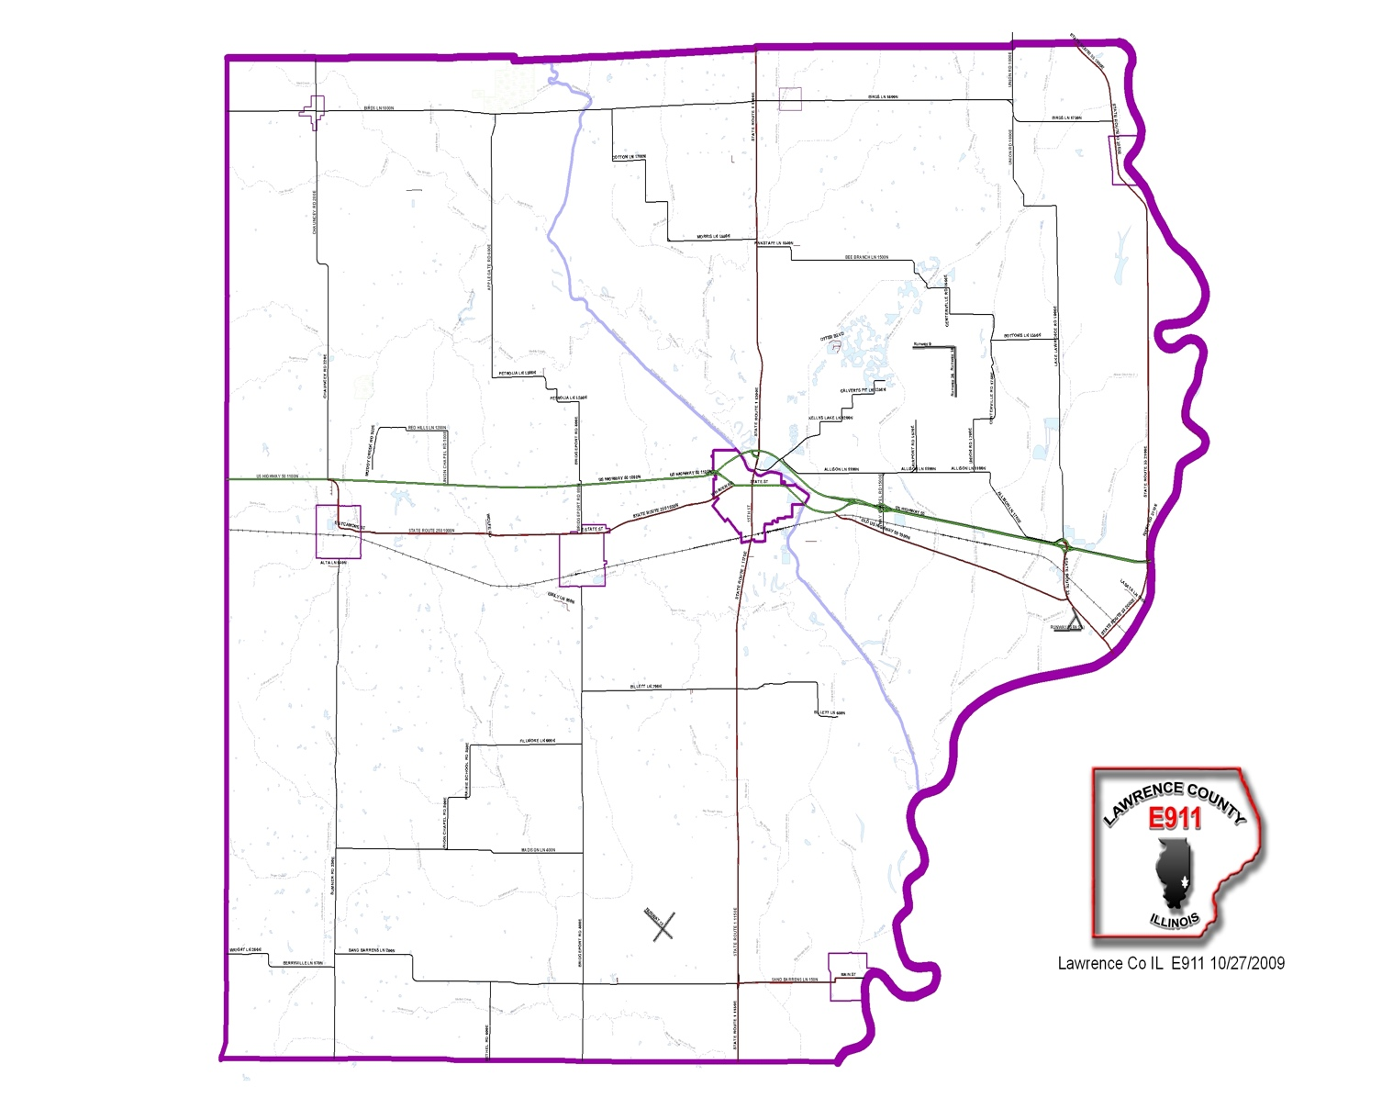

Appendix E
Lawrence County
Flood Evacuation Plan

Table of Contents

Mission 2
Situation and Assumptions 2
Direction and Control 3
Concept of Operations 3
Administrative Support 3
Special Needs Population 4
Transportation 5
Shelters 6
Hazardous Materials Response 7
Coordinator Contact List 8
Public Information 9

Lawrence County
Flood Evacuation Plan

- Mission
To ensure that mechanisms exist to safely evacuate endangered persons from an area when evacuation does not pose a greater risk than leaving those persons in place.

- Situation and Assumptions
- The need to evacuate part or all of the Lawrence County flood plain population may be caused by a variety of hazards.

- All decisions about when to evacuate, how to evacuate, what to evacuate and where the evacuees will be directed are the responsibility of the County Board Chairman, Levee Commissioners, County Sheriff, and the Fire and Police Chief’s.

- When a dangerous situation exists, 50% of the population may spontaneously leave. They will seek shelter with family, friends, or through commercial lodging.

- Alternate transportation and manpower will need to be arranged for those citizens that require it.

- It will be necessary to open shelters in compliance with this plan.

- The County and Cities will need to address medical response/support to an evacuation.

- The County and Cities will need to address special transportation requirements and traffic control.

- The County and Cities will need to discuss the provision of security in evacuation areas.

- The County and Cities will need to discuss the impact of pets during an evacuation.

- Public Information will be conducted in compliance with this plan.

- Direction and Control
Direction and control is the responsibility of the County Board Chairman and Mayor. This responsibility can be delegated.

- Concept of Operations
- Shelters should be identified in advance on page 6 of this plan.

- Evacuations as a result of a release of a hazardous material will be in compliance with provision on page 7 of this plan.

- Shelters for evacuees from a flood should be located above the 100-year flood plain.

- Administration Support
Administrative support is the responsibility of the County and Cities. Additional information can be obtained through the County Emergency Operation Plan, Resource Manual, and/or the Local Emergency Planning Committee All Hazard Plan.

Special Needs Population

Location and Contact Information | Max Capacity | # of Employees
Crown Point, CILA  Sumner, IL 62466  Andrea Burkett  618-936-2903 | 8 | 6
Hickory Estates, Group Home  Sumner, IL 62466  Sheila Hayes  618-936-2004 | 16 | 14
Lawrence Community Health Care  900 Corporation Street, Bridgeport, IL 62417  Rob Gillis, Administrator  618-945-2091 | 82 | 112
United Methodist Village  1616 Cedar, Lawrenceville, IL 26439  Carol Brown, Administrator  618-943-3347 | 163 | 160
United Methodist Village – North Campus  2101 James, Lawrenceville, IL 62439  Levi Burke, Administrator  618-943-3444 | 121 | 90
West Grove, Group Home  Lawrenceville, IL 62439  Randy Gravitt  618-943-3347 | 16 | 11

Transportation

Facility | Contact Information | # of Vehicles
Lawrence County Health Department | Phyllis Wells, Administrator  618-943-3302 | 2 special needs vans  1 mini van
Unit 10 School District | Matt Seaton, Superintendent  618-945-2061 | 6 full size school buses
Unit 20 School District | Charles Stegall, Superintendent  618-943-2326 | 6 full size school buses

Shelters

Facility | Contact Information | Type | Kitchen | Seats | Sleeps
Christy Fire Protection Dist  109 E North Avenue  Sumner, IL 62466 | District Chief  618-562-5800 | Fire Dept | None
Lawrence/Allison Fire Protection Dist  RR 1  Lawrenceville, IL 62439 | Mike Mefford, Chief  812-305-8415 | Fire Dept | None
Parkside Elementary School  1900 Cedar  Lawrenceville, IL 62439 | Barbara Large  618-943-3992 | School | Full
Red Hill High School  908 Church Street  Bridgeport, IL 62417 | Principal  618-945-2521 | School | Full

Hazardous Materials Response

Bodine Environmental Services
5350 E. Firehouse Road
RR 2 Box 35
Decatur, IL 62521
Bob Caplinger
217-428-3629

Coordinator Contact List

Position | Contact Information
County Board Chairman | Charles Gillespie  1906 Lexington  Lawrenceville, IL 62439  618-943-3075
Lawrenceville Mayor | Brian Straub  1214 State Street  Lawrenceville, IL 62439  618-943-4946
Lawrence/Allison Fire and Rescue | Mike Mefford, Chief  700 State Street  Lawrenceville, IL 62439  618-943-6412
Lawrence County Sheriff | Russell Adams, Sheriff  1306 Lexington  Lawrenceville, IL 62439  618-943-5766
Lawrence County EMA | Gerald “Jess” Angle, Coordinator  109 E North Avenue  Sumner, IL 62466  618-562-5800
Lawrence County Health Department | Phyllis Wells, Administrator  RR 3 Box 414  Lawrenceville, IL 62439  618-943-3302

Public Information

Newspapers
The Bridgeport Leader
131 E Oliver Street
Bridgeport, IL 62417
Barbara Allender
618-936-9310

The Daily Record
1201 State Street
Lawrenceville, IL 62439
Ashley Smith
943-2331

Broadcast Radio Station
WAKO 103FM and 910AM
Business 50
Lawrenceville, IL 62439
Steve Anderson
618-943-3354

Broadcast Television Stations
WTHI, Channel 10
918 Ohio Street
Terre Haute, IN 47808
812-232-9481

WTWO, Channel 2
10849 North US 41
Terre Haute, IN 47802
812-232-9504

Cable Television
Avenue broadband
2603 Hart Street
Vincennes, IN 47591
812-895-7676

