Table of Contents

Description | Pages | Appendices
Forward | 1 – 9
Basis Plan | 1 – 29 | A – G
Required Annexes
Direction and Control | 1 – 30 | A – D
Communication | 1 – 10 | A – C
Warning/Emergency | 1 – 13 | A -
Public Information | 1 – 17 | A – E
Disaster Intelligence/Damage Assessment | 1 – 9 | A – D
Evacuation | 1 – 24 | A – E
Mass Care | 1 – 13 | A – B
Health and Medical | 1 – 18 | A - D
Mortuary Services | 1 – 8 | A – D
Resource Management | 1 – 19 | A – D
Hazardous Material | 1 – 10 | A -
Earthquake | 1 – 38 | A – C
Terrorism | 1 – 23 | A – B
Other Annexes (Optional)
Public Works | 1 – 13 | A – G
Law Enforcement | 1 – 8 | A – D
Fire Service | 1 – 10 | A – F
Emergency Operations Center | 1 – 19 | A – F
Emergency Medical Service | 1 – 13 | A – E
Spontaneous Volunteer | 1 – 12 | A – F
Weather | 1 – 10 | A – E
Acronyms | 1 – 19
Terms and Definitions | 1 – 137

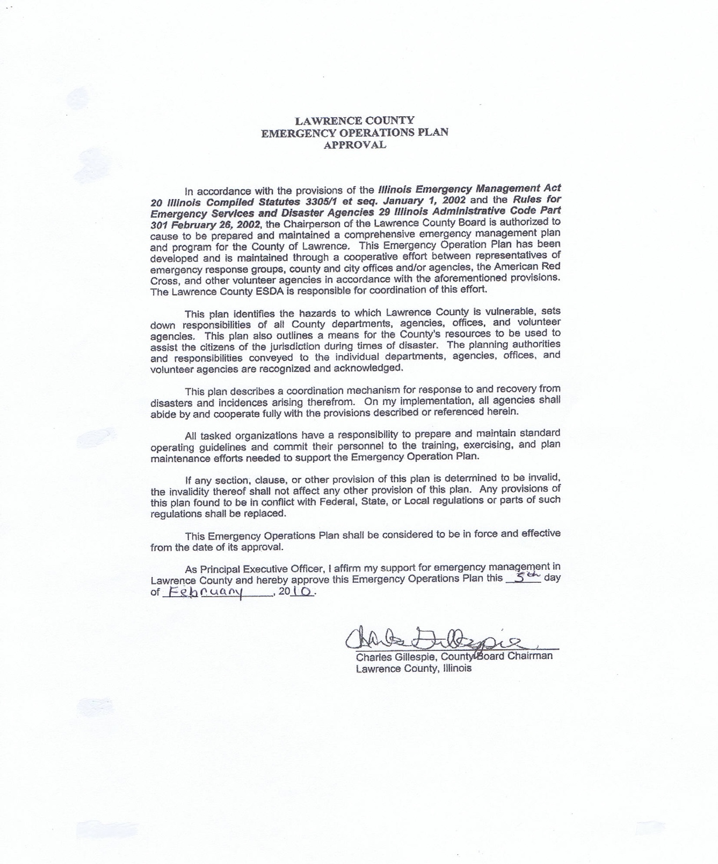
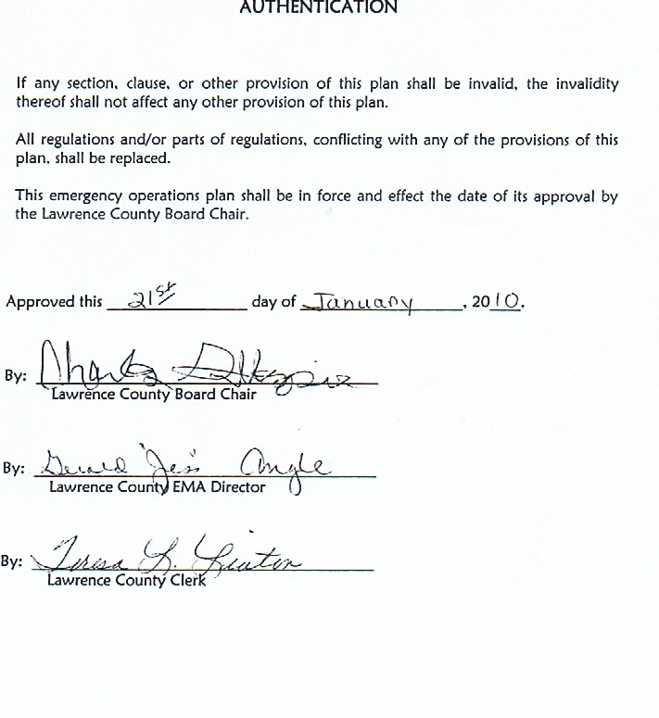

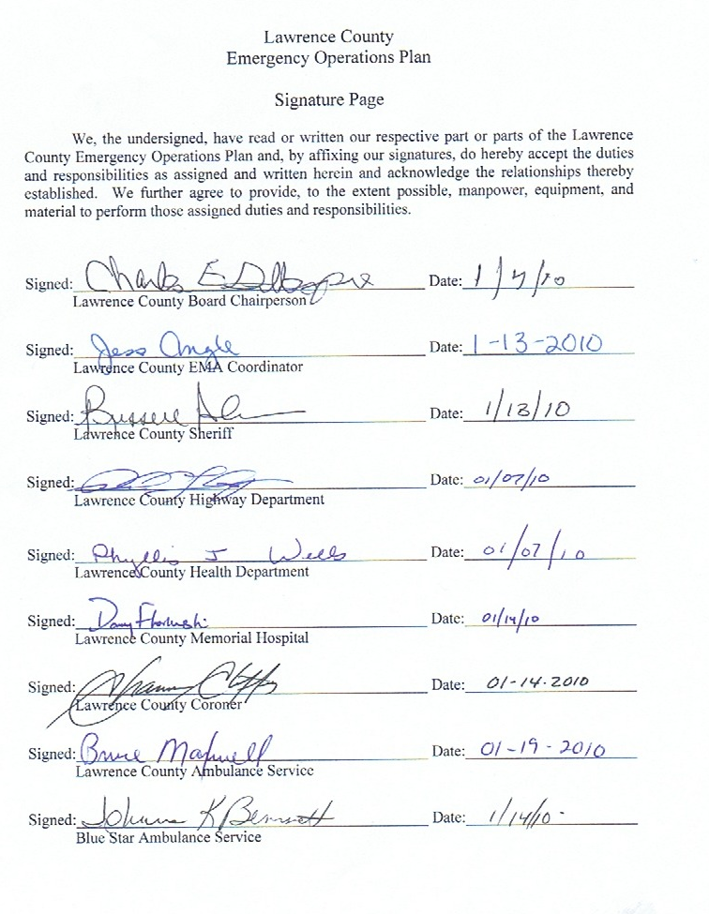

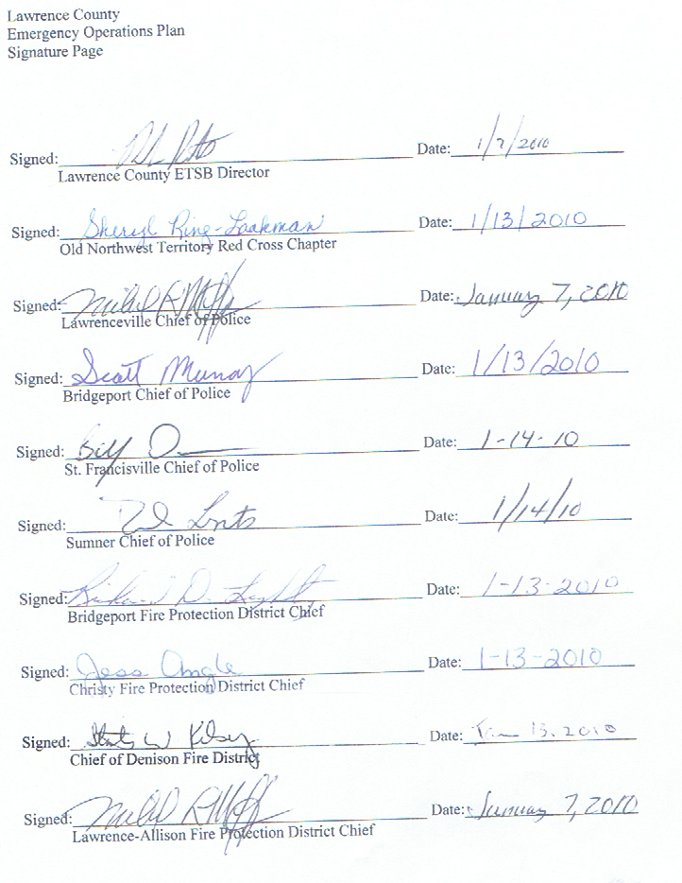

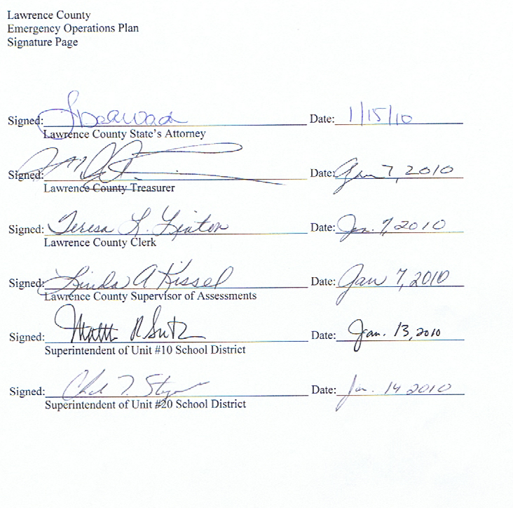

RECORD OF DISTRIBUTION

No. | CD | Hard  Copy | Agency
1. | X | X | Lawrence County EMA
2. | X | X | Illinois Emergency Management Agency, Region 9
3. | X | X | Lawrence County Board Chair
4. | X | X | Lawrenceville City Police Department
5. | X |  | Lawrenceville City Mayor
6. | X | X | Lawrence County Sheriff’s Department
7. | X |  | Lawrence County Highway Department
8. | X |  | Lawrence County Health Department
9. | X |  | Lawrence County Coroner
10. | X |  | Lawrence County E911 PSAP
11. | X |  | Lawrence County Ambulance Service
12. | X |  | Old Northwest Chapter of Red Cross
13. | X |  | Blue Star Ambulance Service
14. | X | X | Lawrence County Memorial Hospital
15. | X |  | Lawrence County Animal Control Warden

Record of Changes

When changes are made to this plan, the following procedures should be followed.

Major changes will be included on the CD issued by Lawrence County EMA.
When any change is made, an entry should be made on the following log.

Change  Number | Date  Entered | Pages or Sections changed | Entered By
1 | 02-17-06 | Approval Pg & Signature Pg | G. Angle
2 | 02-17-06 | Basic Plan 1 – 2 County Ord | G. Angle
3 | 02-17-06 | Annex A, page 16, A-5, A-6 | G. Angle
4 | 02-17-06 | Basic Plan 11-16 | G. Angle
5 | 02-17-06 | Annex F-3, F-4 | G. Angle
6 | 02-17-16 | Annex G-4, G-5 | G. Angle
7 | 02-18-06 | Annex H and Organization Chart | G. Angle
8 | 02-18-06 | Annex H-5 to 8 & 12 to 17 | G. Angle
9 | 02-18-06 | Annex K-10, 11 | G. Angle
10 | 02-18-06 | Annex M-3 | G. Angle
11 | 02-19-06 | Annex N-18 to 20 and 40 to 42 | G. Angle
12 | 02-19-06 | Annex N-43, 44 and 52, 53 | G. Angle
13 | Jan 2010 | Complete makeover | G. Angle
14 | May 2010 | Basic Plan pg 3-IV-B | G. Angle
15 | May 2010 | Basic Plan Pg 13- IX-A | G. Angle
16 | May 2010 | Basic Plan ph 14- XI-XII | G. Angle
17 | May 2010 | Direction Cont. ph 16-17 App. A-B | G. Angle
18 | May 2010 | Comm. pg. 2-B- item 4 | G. Angle
19 | May 2010 | Warn- Emergency pg 2- omit 9 | G. Angle
20 | May 2010 | Warn- Emergency pg 3-E | G. Angle
21 | May 2010 | Dia-Itell – pg 5- VI –omit D | G. Angle
22 | May 2010 | Evacuation Pg 10 (L) | G. Angle
23 | May 2010 | Mass Care pg 3- 12-C | G. Angle
24 | May 2010 | Res. Manage pg 12-2a | G. Angle
25 | May 2010 | Hazmat pg 1-III | G. Angle
26 | May 2010 | Earthquake pg1-1 | G. Angle
27 | May 2010 | Earthquake pg 37-App. C | G. Angle

Plan Abstract

The Basic Section of the Lawrence County Emergency Operations Plan is an overview of the approach to emergency management in Lawrence County. It establishes the general foundation for coping with major emergencies and disasters. The Basic Section explains the general concept of operations and assignment of responsibilities for emergency planning and operations.

The functional annexes to the Emergency Operation Plans provides more information for carrying out assigned tasks. It emphasizes responsibilities, tasks, procedures, and actions that relate to the function being covered (Public Information, Public Health, etc.). The annexes are written for emergency responders of Lawrence County.

Checklists appear at the end of each functional annex. These are intended as a quick reference for the assigned tasks, responsibilities, procedures, and actions that are appropriate for that particular annex.

Planning Goals

Lawrence County EMA’s goal is to promote emergency preparedness. In developing this plan, our intention is to unite all responding agencies. This plan is intended to help all agencies to overcome the short falls that the county experienced during the Flood of 2008. Since then we have moved into our EOC and installed a radio system consisting of Star-Com, Low-Band, and Conventional VHF. We have increased our training and continue our NIMS training as well.

